205.01 Transitional Medicaid Assistance 2
205.01.01 Transitional Period 1: Up to 12 months 3
205.01.02 Transitional Medicaid Period 2: First 6 months 5
205.01.03 Transitional Medicaid Period 2: Second 6 months 6
205.02 MEDS Procedures – Transitional Medicaid Assistance (TMA) Screen 7
205.02.01 MEDS – Reporting Gross Monthly Earnings For TMA Period One 8
205.03 Cúram Procedures – Transitional Medicaid Assistance (TMA) Screen 11
205.04 Calculating Income Received from Quarterly Report 12
205.05 Terminations 13
205.06 MEDS Procedures – Adding New Members to an Existing TMA Budget Group 14
205.07 SSI Individuals 16
205.08 TMA Flow 16
205.09 Processing PCR to TMA Change 18
205.10 Processing TMA Quarterly Reports 20

205.01 Transitional Medicaid Assistance
(Rev. 04/01/23)
The primary purpose for providing Transitional Medicaid Assistance (TMA) benefits is to ensure that healthcare coverage is available to individuals who lose Parent/Caretaker Relative (PCR) Medicaid when they enter or re-enter the work force. A separate application is not required. PCR families are eligible to receive TMA if the family was eligible for PCR in the application month and received PCR immediately preceding the month in which the family became ineligible due to:
- An increase in the earnings of the parent or caretaker relative;
- An increase in the number of hours the parent/caretaker relative is employed;
- The addition of a parent or caretaker relative with earned income; or
- An addition or increase in alimony income received by a parent or caretaker relative.

TMA can also be provided for up to four months for an addition or increase in alimony income received by a parent or caretaker relative. See note below for additional details.
Note
- Alimony payments made under a divorce or separation agreement executed on or before Dec. 31, 2018, are deductible from the income of the payer spouse and countable as income of the receiving spouse.
- Beginning Jan. 1, 2019, alimony payments made under a divorce or separation agreement executed after Dec. 31, 2018, are not deductible from the income of the payer spouse, or countable as income of the receiving spouse.
- If a divorce or separation agreement executed on or before Dec. 31, 2018, is modified after December 31, 2018, alimony payments are not deductible from the income of the payer spouse, or countable as income of the receiving spouse if the modification:
  - changes the terms of the alimony or separate maintenance payments; and
  - states that the alimony or separate maintenance payments are not deductible by the payer spouse or countable as income of the receiving spouse.

If the loss of PCR coverage is due to the receipt of alimony as indicated above, then the beneficiary will only move to TMA2 for 4 months.

TMA benefits may be available for up to 24 months. Continuous coverage is dependent upon:
- the continuing existence of earned income in the household,
- the continued inclusion of a dependent child(ren) in the household, and
- cooperation in the completion of required quarterly reports.

The continuous coverage begins the month the beneficiaries move into TMA eligibility. If all requirements are met a beneficiary can be eligible up to a 24-month period. If the family loses coverage due to moving out of state and moves back within their TMA1 or TMA2 periods, coverage can be re-instated without a new application being required.

There are two distinct periods of TMA eligibility: Transitional Period 1 (State Program- the 1st 12 months), and Transitional Period 2 (Federal Program-divided into two 6-month periods).

205.01.01 Transitional Period 1: Up to 12 months
(Rev. 04/01/23)
The Transitional Period 1 (TMA1) may begin at the point when earnings or hours of employment cause income to exceed the PCR income limit. TMA1 is also available when a Parent/Caretaker Relative with earned income loses eligibility at the first annual review or redetermination completed after April 1, 2014. During this period a conditional disregard is applied that disregards all earned income up to an amount equivalent to 185% of the FPL for 12 months. The 185% is in addition to the 5% FPL income disregard. During this extended period, the case moves to Payment Category 11.

The first 12-month count begins at the point the change causes ineligibility, whether the income is reported timely or not. Example: Income increased in February 2022 and reported in April of 2022. In February 2022, the beneficiary received one (1) check with the increased income of $400.00. In March 2022the beneficiary received four (4) weekly checks with the increased amount of $400.00. Although the increase occurred in February, the beneficiary is still eligible for February, based on the amount received. The amount received in March makes the beneficiary ineligible, so the 12-month count begins in March 2022 and ends effective March 1, 2023.

TMA Effective Date When Using SCDEW Wage Income Quarters as Verification
The effective date will be the first month of the quarter in which the beneficiary is ineligible for PCR benefits. Example: The beneficiary returns a review form in April 2023. They do not provide proof of income along with the review form. The eligibility specialist checks Person Composite Service (PCS) for income verification. PCS shows that the beneficiary’s income increased past the PCR income limit in Q4/2022. The TMA effective date would begin in October 2022.

Quarter that Wages Increased | TMA Effective Date
First Quarter (Q1) | January
Second Quarter (Q2) | April
Third Quarter (Q3) | July
Fourth Quarter (Q4) | October

Note: The chart should only be referenced when using SCDEW Wage Income Quarters as verification.

TMA Effective Date When Using Self-Employment Income as Verification
The effective date for self-employment income will be the January following the tax filing year, unless otherwise indicated. For instance, any self-employment income filed for Tax Year 2022 is counted with an effective date of January 2022. Example: The beneficiary returns a review form in June 2023. They provided their complete 2022 tax return in which their income increased past the PCR income limit. The TMA effective date would begin in January 2023.

All PCR rules continue to apply. As a result, there may be instances where reported changes in the household may result in ineligibility or in movement back to PCR or to Transitional Medicaid Period 2 prior to the end of the 12-month period.

Countable income in excess of the PCR net income limit if due to other than earned income may result in ineligibility for the extended coverage. Countable income in excess of the PCR net income limit because of increased earned income (or hours of employment) results in movement to TMA Period 1. The family is eligible to receive TMA Period 1, if the family was eligible for and received PCR coverage in the month immediately preceding the month in which the family became ineligible for PCR. Only the parent/caretaker relative(s) should be ex parted to the TMA payment category. However, if dependent child loses PHC/CHIP coverage after the start of TMA the child can be moved into the TMA payment category with their parent for the remaining time.

At the end of the TMA1 period, a notice must be mailed to the beneficiary that offers to continue Medicaid for up to an additional 6 months without re-application (start of TMA2).

For TMA cases entered into Cúram:

The eligibility specialist will determine the start of the TMA1 period and TMA2 period. The effective dates will then be entered into the TMA Details section of the Insurance Affordability case. The system will generate the quarterly report dates. These dates should not be altered once they are keyed in unless they were determined by error. The eligibility specialist will then add the TMA Manual eligibility for the parent/caretaker.

Please refer to MPPM Chapter 702 for the treatment of potential TMA households following the Public Health Emergency, and receipt of the first review following the PHE.

TMA Coverage Family Previously Eligible in SC Moving to Another State
If a family that was eligible and receiving TMA prior to moving out of state returns to the state of SC, a new application is not required to re-instate coverage if they are still within their possible 24-month timeframe.

Example 1: If a family moves into TMA as of January 2023, they will have the potential for 24 months of TMA coverage until January 2025. If the family begins their TMA coverage and reports they have moved as of June 2023, then later report in August 2023 they have moved back to the state of SC, they may be re-opened under TMA without the need for a new application. Since the household would be within their TMA1 Period, no quarterly reports would have been sent out. They should show a gap of coverage from July 1, 2023, to July 31, 2023. The TMA eligible beneficiaries would resume their coverage, and the dependent children would re-start PHC coverage as of August 1, 2023.

Example 2: If a family moves into TMA as of February 2023, they have the potential for 24 months of TMA coverage until February 2025 if all requirements are met. The family moves into their TMA2 period and returns their completed first quarterly report. They later report to DHHS in June 2024 that they have moved out of state. The system is updated, and coverage ends on July 1st. The family then reports in October of 2024 that they have moved back to our state. TMA can be reopened as of October 1st and a new application will not be required as they are still within their TMA2 Period, have returned their first quarterly report timely, have not had an increase in income, and still have a dependent child in the household. However, they will show a gap of coverage from July 1, 2024, until September 30, 2024. The TMA period will still be set to end February 2025 if all other requirements are met.

205.01.02 Transitional Medicaid Period 2: First 6 months
(Rev. 04/01/23)
This transitional period is available immediately after the loss of the earned income disregards, or the point at which earnings or hours of employment cause income to exceed the PCR net income limit. TMA Period 2 provides up to 2 six-month periods of continued eligibility unless:

- The family ceases to include a dependent child;
- There ceases to be earned income (unless Good Cause) or;
- The family reports a move out of state. (Note: If the family returns before TMA Period 1 ends, restore benefits for the remainder of the period).

Procedure for Restoring TMA Benefits

For an existing TMA case in MEDS not yet converted to Cúram

Take a new application in MEDS for PCAT 59. Deny the PCAT 59 Budget Group and ex parte to PCAT 11. The TMA Status and the TMA Status Effective Date from the original PCAT 11 BG will need to be entered on ELD60 for the new PCAT 11 BG.

Cúram Procedures:

For an existing TMA case in Cúram

TMA eligibility is driven by the TMA details. The eligibility specialist should review the new application or reported change to update the evidence within the Evidence Dashboard within the Insurance Affordability case. If the household will continue with TMA coverage, review the dates within the TMA Details screen. The effective start date should remain the same. Only the end date should be updated to allow Manual Eligibility under PCAT 11 to be updated. If the household should have a period of no coverage (i.e., they moved to another state, then report that they moved back to SC) the eligibility specialist should enter Benefit Evidence details with the appropriate start and end dates to create a block in coverage.

Earnings are budgeted prospectively. The 6-month count begins with the first month that the wages plus any other income actually received exceeds the PCR limit, whether the income is reported timely or not.

During TMA Period 2, all income is disregarded for the first 6 months.

A quarterly report must be generated and mailed to the beneficiary by the system (refer to MPPM 205.06.06) in the 3rd month and must be returned by the 21st day of the 4th month of TMA Period 2, to determine if coverage will be available for months 7-12.

205.01.03 Transitional Medicaid Period 2: Second 6 months
(Rev. 04/01/23)
Provide this conditional transitional period for an additional six months if:

- The family continues to include a dependent child;
- The family returned the 1st quarterly report timely;
- The family’s gross earned income (less childcare expenses) is less than or equal to 185% of the FPL for the family size;
- The Parent/caretaker relative continued to have earned income for each month of the preceding 3-month period;
- The family continues to reside in the state;
- The family completes and returns two additional quarterly reports, by the 21st day of months 7 and 10 (TMA Period 2).

Note: If the caretaker relative did not have earned income in the preceding 3-month period, the eligibility specialist needs to check to see if the lack of earnings was due to illness, involuntary loss of employment, or good cause.

If YES, continue TMA benefits.

If NO, discontinue benefits; however, do not close the case until reviewing the information in the case to see if the family qualifies under any other Medicaid coverage group.

Base Continued Eligibility for TMA on income reported on the quarterly reports returned by the beneficiary. Use the Electronic Budget Workbook to calculate income received in each of the reporting months.

Good cause for lack of earnings includes but is not limited to: family crisis; court required appearance or incarceration; loss of transportation where no other means of transportation is readily accessible; or loss of child care arrangements. Allegation of “good cause” on the quarterly report is sufficient documentation.

205.02 MEDS Procedures – Transitional Medicaid Assistance (TMA) Screen
(Rev. 04/01/23)
Use MEDS procedures for beneficiaries who are currently eligible for:

- TMA in MEDS; or
- LIF/PCR in MEDS and prior to the date Cúram becomes available, lose eligibility due to a reported change.

The begin date of the TMA Period 1 period must be documented on the Transitional Medicaid Screen (ELD60) in MEDS.

Once the eligibility specialist completes Act on Decision to approve a PCAT 11 budget group in the Extended LIF period, an information notice (ELD065) will be generated by MEDS informing the beneficiary that benefits have been extended for up to one year. The notice will inform the applicant/beneficiary to report within ten (10) days, if they:
- Have a loss of earned income
- Have an increase in earned or unearned income
- Have a change in child care payments
- Have a change of address for any or all members of the budget group, or;
- The household ceases to include a dependent child

The TMA screen is accessible from the Eligibility Decision (ELD) Menu in MEDS. The screen is identified as ELD60.

The following fields are updateable by eligibility specialist on ELD60:
- “EXT LIF Status”
- “EXT LIF Status Effective Date”
- “TMA Status”
- “TMA Status Effective Date” and
- “Received”

The valid values for the “EXT LIF Status” field are as follows:
- “IE” (Increase in earned income of the caretaker)
- “IH” (Increase in hours worked by the caretaker)

The valid values for the “TMA Status” field are as follows:
- “IE” (Increase in earned income of the caretaker)
- “IH” (Increase in hours worked by the caretaker)
- “EE” (Excess earnings in EXT PCR)
- “ET” (Excess earnings-skip EXT PCR period) and
- “GC” (Good Cause -loss of earnings by the caretaker due to involuntary loss of employment). “GC” can only be used if the previous “TMA Status” was IE, IH, LD, EE or ET.

The “EXT LIF Status Effective Date” entered by the eligibility specialist should indicate the month and year that the increased income causes the budget group to exceed the PCR limit whether the income is reported timely or not. The eligibility specialist cannot update the “EXT LIF Status Effective Date” once a Budget Group has been approved. The MEDS Helpdesk must be contacted for assistance if the “EXT LIF Status Effective Date” needs to be adjusted on an active Budget Group.

Exception: If the eligibility specialist enters “ET” in the “TMA Status” field, the “EXT LIF Status” field will be blank on the TMA screen.

The “Received” field is the date the quarterly report was received. All other data is displayed for information purposes only. The screen contains important information regarding the PCAT 11 budget group including:
- The dates the quarterly reports are to be mailed out
- The months included on each quarterly report
- The dates the quarterly reports are generated by MEDS
- The dates the quarterly reports are due back
- The dates the quarterly reports are received by the eligibility specialist
- The “EXT LIF Status”, “EXT PCR Status Effective Date”, “EXT LIF Period”
- The “TMA Status”, “TMA Status Effective Date”
- The date each TMA period begins and ends; and
- The Anticipated Closure Date (ACD)

205.02.01 MEDS – Reporting Gross Monthly Earnings For TMA Period One
(Rev. 04/01/23)
At the beginning of TMA Period 2, the system sends a TMA approval notice (ELD63), to the beneficiary that offers to continue Medicaid for up to 6 months without reapplication. The notice will be generated by the SOR and will include a statement advising the family of its right to TMA.

To maintain eligibility for the entire 12-month period, the family must report gross monthly earnings and childcare costs on a quarterly basis. Computer-generated Transitional Medicaid Assistance (TMA) quarterly reports will be sent to each household on or around the 15th day of the 3rd, 6th and 9th month of the transitional period for TMA2. For each month that the TMA quarterly reports are mailed, the beneficiary will be asked to report changes in earned income, household composition, and the cost of childcare.

The TMA quarterly reports must be completed and signed by the beneficiary and returned to the eligibility specialist by the 21st day of the month following the month in which the quarterly report was received, regardless of whether there have been any changes in the beneficiary’s circumstances.

The eligibility specialist must re-determine eligibility based on the information provided in the TMA quarterly report and accompanying verification as well as eligibility criteria for period 2.

4-Month Quarterly Report
- The family is notified that they must report by the 21st day of the fourth month (TMA Period 1) the earnings of the parent/caretaker relative, the family’s gross monthly earnings and the costs for childcare to the parent/caretaker relative, for months 1, 2, and 3.
- If the report is not received by the 21st day of the 4th month, the case will close effective with the first day of the 7th month. The “Received” date must be updated by the 22nd day of the 4th month.
- Do not indicate in the SOR “Received” if the quarterly report is returned without the beneficiary’s signature.
- Budget the case based on the income stated on the quarterly report if it is consistent with electronic data sources.
- Use the amount paid for childcare as stated on the quarterly report

7-Month Quarterly Report
- The family is notified that they must report the earnings of the parent/caretaker relative, the family’s gross monthly earnings and the cost for childcare to the parent/caretaker relative by the 21st day of the seventh month (TMA Period 2) for each of months 4, 5, and 6.
- If the report is not received by the 21st day of the 7th month, the case will close effective with the first day of the earliest possible month. The “Received” date must be updated by the 22nd day of the 7th month.
- Do not indicate in the SOR “Received” if the quarterly report is returned without the beneficiary’s signature.
- Budget the case based on the income stated on the quarterly report if it is consistent with electronic data sources.
- Use the amount paid for childcare as stated on the quarterly report

10-Month Quarterly Report
- The family is notified that they must report the earnings of the parent/caretaker relative, the family’s gross monthly earnings and the costs of childcare to the parent/caretaker relative for each of months 7, 8, and 9, by the 21st day of the 10th month (TMA Period 2).
- If the report is not received by the 21st day of the 10th month, the case will close effective with the first day of the earliest possible month. The “Received” date must be updated by the 22nd day of the 10th month.
- Do not indicate in the SOR “Received” if the quarterly report is returned without the beneficiary’s signature.
- Budget the case based on the income stated on the quarterly report if it is consistent with electronic data sources.
- Use the amount paid for childcare as stated on the quarterly report

Procedure

If the beneficiary does not return the completed and signed TMA quarterly report by the 21st day of the month following the month in which the report was received, the system will close the case effective with the first day of the earliest possible month. The case cannot be exparted. The SOR will send the appropriate termination notice (ELD001).
Exception: If there is a child in the case with a Protected Period (PPED), the child will remain eligible. The Anticipated Closure Date (ACD) will be reset to the child’s PPED plus one day. Should there be more than one child remaining in the Budget Group, the ACD will be set to one day after the latest PPED. The parents will receive a closure notice (ELD30), along with a “Certificate of Creditable Coverage”

If a TMA quarterly report is returned after the 21st day, the case cannot be reopened and the report cannot be treated as a Medicaid application. The beneficiary will have to re-apply for Medicaid.
Procedure in MEDS:

Enter the date the completed form was returned in the “Received” field on ELD60 (Transitional Medicaid Assistance screen)

If after re-determining eligibility the case becomes ineligible, close the case with the appropriate reason code in the RC1 field on ELD01. MEDS will send the termination notice.

NOTE: The BG cannot be closed for excess income (RC 051) or failure to return a completed quarterly report (RC 092) during TMA Period 1. These closures must be effective the first day of the 7th month or after.)
If there are children in the case with a PPED, Medicaid will continue for them.

MEDS will send a closure notice (ELD30) along with a “Certificate of Creditable Coverage” (ELD001) to the parents.

205.03 Cúram Procedures – Transitional Medicaid Assistance (TMA) Screen
(Rev. 04/01/23)
Transitional_Medicaid_Assistance.pdf
Transitional_Medicaid_Assistance_Quarterly_Reporting.pdf

Use Cúram procedures for beneficiaries who are currently eligible for:

- TMA, or
- LIF/PCR in MEDS and need to be moved to Cúram, lose eligibility due to a reported change.

The begin date of the TMA Period 1 or TMA Period 2 must be documented on the Transitional Medicaid Details evidence in Cúram. If the client will move into TMA 2 initially, then a TMA1 period is not required.

Once the eligibility specialist completes the addition of TMA details and Manual Eligibility in the Insurance Affordability case, an information notice will be generated by Cúram informing the beneficiary that benefits have been extended for up to one year. The notice will inform the applicant/beneficiary to report within ten (10) days, if they:
- Have a loss of earned income
- Have an increase in earned or unearned income
- Have a change in child care payments
- Have a change of address for any or all members of the budget group, or;
- The household ceases to include a dependent child

Remember, the beneficiaries TMA Details must be enter prior to entering Manual Eligibility under the TMA category (PCAT 11).

The following fields are updateable by eligibility specialist within the TMA Details screen:
- “Reason for Change”
- “TMA1 Effective Date” – Enter the date the change was effective. This cannot be a future date and must be the first of the month.
- “TMA2 Effective Date”- Enter the date the change was effective or 12-months after the TMA1 Effective Date if the client did not go straight into TMA2.
- No comments need to be entered into this screen.

The eligibility specialist should verify the updated TMA Details:
- Projected TMA timeline dates for TMA1 and TMA2 will display.
- Quarterly Report request dates will display.

The projected TMA Timelines field will show the quarterly report dates. The screen contains important information regarding the TMA coverage category including:
- The dates the quarterly reports are to be mailed out by the system.
- The dates the quarterly reports are due back.

The “TMA1” or “TMA2” dates entered by the eligibility specialist should indicate the month and year that the increased income causes the beneficiary to exceed the PCR limit whether the income is reported timely or not. The eligibility specialist should not update the TMA Details screen once they have been entered unless the dates were keyed in error.

Once the dates have been set the current TMA type will display either as TMA1-State Program or TMA2- Federal Program respectively.

The eligibility specialist then should enter the Manual Eligibility details into the Insurance Affordability case. The dates for the beneficiary’s manual eligibility must match the dates entered in the TMA Details record.

Once a quarterly report is generated and/or received the eligibility specialist will see an updated the QR Request status displayed:
- Quarterly Report Completed
- Insufficient Information Received
- Quarterly Report Not Received
- Quarterly Report Not Signed
- or, Quarterly Report Sent

205.04 Calculating Income Received from Quarterly Report
(Rev. 04/01/23)
When calculating income specified on returned quarterly reports, use the gross earned income reported in each of the three months to determine if the Budget Group will continue to be eligible for TMA. Average the total gross income minus the allowable childcare deduction for the three-month period to compute the countable earned income. For self-employment cases, annualize the income using the most recent tax return the individual has on file with the IRS.

Note: For TMA, allow actual dependent care expenses up to $200 per month per child under age 12. The amount for dependent care expense (childcare) is self-attested from the beneficiary. Reduce by the amount of any ABC Childcare Assistance. Do not allow the deduction for an incapacitated adult.

Example: John Johnson returned his TMA quarterly report for the months of April, May and June with his income and childcare expenses. He has one child age 5.

Month | Gross Earned Income | Allowable Child Care | Countable Earned Income
April | 2500.00 | 200.00 | 2300.00
May | 2100.00 | 200.00 | 1800.00
June | 1950.00 | 200.00 | 1650.00
Total | 6550.00 | 600.00 | 5950.00

Divide the total Countable Earned Income by three to calculate the average monthly income for the three-month period.
$5950.00 ÷ 3 = 1983.33 – compare this amount to 185% of the FPL for the family size.

205.05 Terminations
(Rev. 04/01/23)
For quarterly reports not received timely:

If the beneficiary does not return the completed and signed TMA quarterly report by the 21st day of the month following the month in which the report was received, the system will close the case effective with the first day of the earliest possible month. If the eligibility specialist finds the beneficiary has not returned all the needed income for the quarterly report before the 21st day, the specialist should first complete a collateral call to the beneficiary. If the collateral call is unsuccessful, a checklist should be mailed to the beneficiary with the due date of the 21st day. The case cannot be exparted because the quarterly report was not returned timely. Refer to the procedures in MPPM 205.02.01.

For quarterly reports received timely:

Should a Transitional Medicaid Assistance case be terminated for any reason outlined in MPPM 205.02, advance notice must be given. Transitional Medicaid Assistance benefits may not be terminated until it has been determined that the family and/or children do not qualify under any other Medicaid coverage group.

To maintain eligibility for the TMA2 period, the family must report gross monthly earnings and childcare costs on a quarterly basis. Cúram-generated Transitional Medicaid Assistance (TMA) quarterly reports are sent to each beneficiary on or around the 15th day of the 3rd, 6th, and 9th months of the TMA2 period.

The TMA quarterly reports must be completed and signed by the beneficiary and returned to the eligibility specialist by the 21st day of the month, following the month in which the quarterly report is received, regardless of whether there are any changes in the beneficiary’s circumstances.

The eligibility specialist must re-determine eligibility based on the information provided in the TMA quarterly report, the accompanying verification, and the eligibility criteria for period 2.

Transitional_Medicaid_Assistance_Quarterly_Reporting.pdf

205.06 MEDS Procedures – Adding New Members to an Existing TMA Budget Group
(Rev. 04/01/23)
Use the following procedures when it is necessary to add new members to an existing TMA Budget Group.

If the additional family member(s) causes the family to be eligible for PCR, a new application is required. Do not require a new application if the family will remain eligible for TMA; however, the eligibility specialist must gather all appropriate information needed to add the member(s) to the household.

MEDS Procedure

Determine eligibility using the MAGI Budget Workbook.

If the addition of the new family member will make the family eligible for PCR:
- Close the current TMA budget group with RC004. The family will not receive a notice.
- Enter a new application in MEDS. Be sure to include the new family member as applying in the new PCR budget group.
- Approve the PCR budget group. Enter the Next Review Date (NRD) on ELD02 based on the “reported income” in the home. If there is no “reported income” in the home, the case must be reviewed in six (6) months.

If the addition of the new family member will keep the family in Extended LIF, TMA period 1 or TMA period 2:
- Close the current TMA budget group with RC004. The family will not receive a notice.
- Take a new application in MEDS to create a new budget group for PCAT 59. Make sure each active member of the TMA budget group and the new family member are applying in the PCR budget group.
- Deny the PCR budget group with RC093 and ex parte each member to a new TMA budget group.

Make sure the new TMA budget group has the same “TMA Status” and “TMA Status Effective Date” as the TMA budget group that was previously closed.

Cúram Procedure

Determine eligibility using a MAGI Budget Workbook with the additional family member(s).

If the addition of the new family member will make the family eligible for PCR:
- Close the current TMA Manual eligibility. Please complete all steps on the same day so the family will not receive a notice.
- Apply changes.
- Click into the TMA Details tab.
- Edit the TMA End Date for the last day of the month in which eligibility is determined to be ended.
NOTE: The TMA End Date must align with the TMA Manual eligibility evidence.
- Complete any additional changes and apply changes.

If the addition of the new family member will keep the family in TMA:
- Take the new application or reported change to add the additional family member to the Insurance Affordability case.
- Open the TMA Details tab and verify dates. Ensure the household has provided timely quarterly reports and should still continue under TMA.
- Create new Manual Eligibility evidence for the new member.
- Select TMA-11, Benefits Code F(Full)
- Enter the Start Date as the first day of the month the change was received.
- Enter the End Date to match the other TMA individuals in the household as the date must match the dates in the TMA Details record.
- Enter the adjusted gross income from the workbook.
- Save and Apply Changes.

205.07 SSI Individuals
(Eff. 01/01/14, Rev. 04/01/14)
For TMA cases entered into MEDS prior to ACCESS becoming available, if an individual receives SSI benefits, he is not included in the transitional budget group. His income and resources, as well as the SSI payment, are disregarded in determining eligibility for the other family members.

205.08 TMA Flow
(Rev. 11/01/2020)
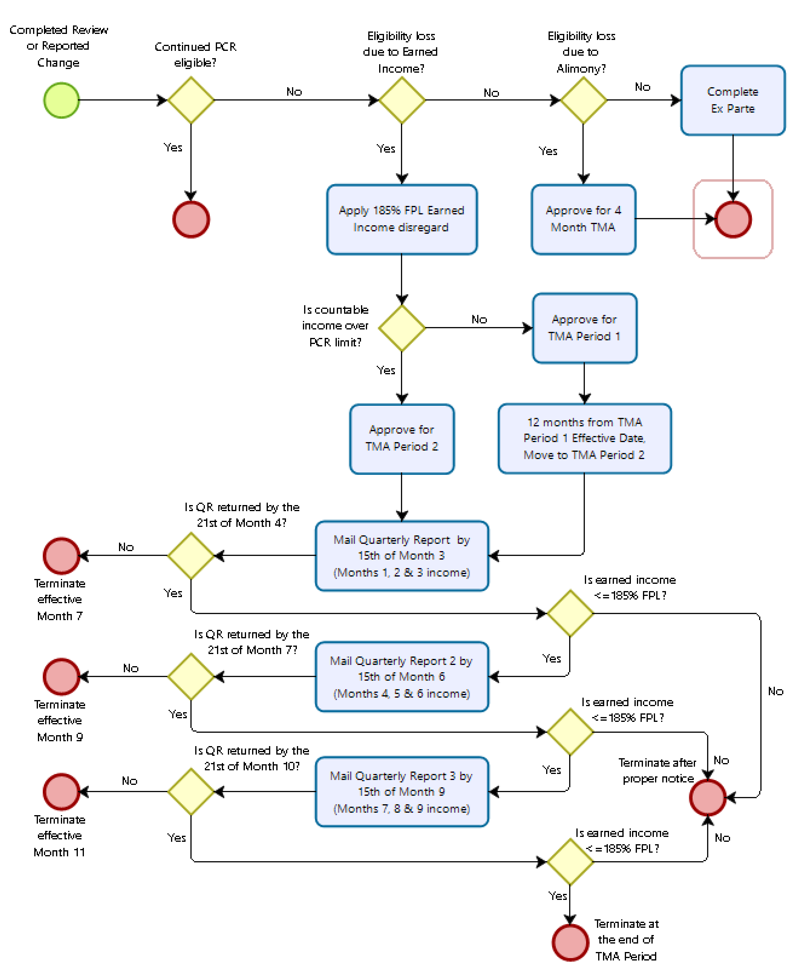

205.09 Processing PCR to TMA Change
(Eff. 04/01/23)
It will be necessary to complete a MAGI workbook to make the proper decision for an individual with a change in earned income.

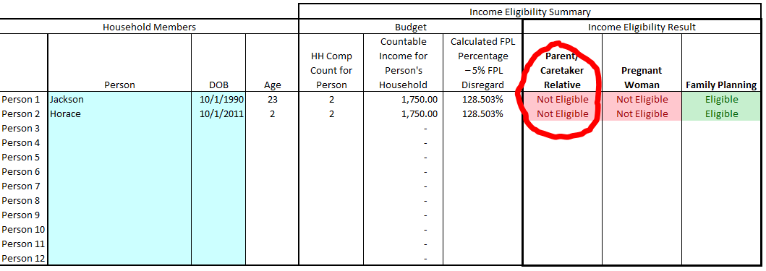
If a PCR eligible client reports a change in earned income, first complete a MAGI workbook to determine if the client remains eligible using MAGI methodology. If eligible, no change is necessary. If the MAGI workbook indicates the client is no longer eligible for PCR and the client or his/her spouse has earned income, open the PCR to TMA tab of the MAGI workbook.

Enter the Household members for the affected client into the first section of the PCR to TMA tab of the workbook, along with each member’s countable income. There is a section for both Gross Earned Income and Gross Unearned Income.
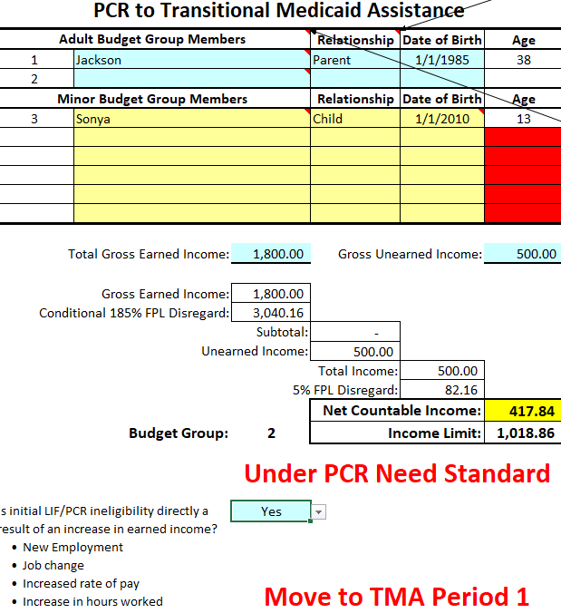
Select the PCR to TMA tab. Once the section is completed a message will display to indicate if after applying the 185% FPL Conditional and 5% FPL Standard disregards the remaining income is above or below the PCR income limit for the HH size. Answer the question below the message to indicate if the change is directly a result of some change in earned income. If the answer is Yes, the workbook will display a message to either move the client into TMA1 or TMA2.

Based on the income verification source used to determine the current household budget, the eligibility specialist will next key information in the bottom section of the PCR to TMA tab.

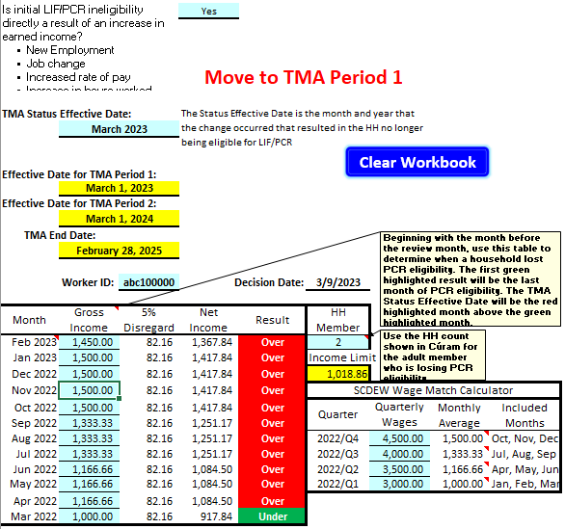
If Equifax paystub entries were used, the worker should list the Gross Income (including any Unearned Income) for each listed month in the lower left side. Based on the amount entered, the workbook will show whether the household was over or under the PCR limit.

If SCDEW Wage Match was used to determine the household income, the worker should list each Quarterly Wage amount as listed in PCS into the lower right side. This will give the worker a monthly average to enter the left side to determine when the PCR change first occurred. The effective date will be the first month of the quarter in which the beneficiary is ineligible for PCR.

If paystubs (and no other source is available, use the average of the check stubs received) or a tax return was used, the entered amount will be the same for all listed months. The effective date for self-employment will be the January following the tax filing year, unless otherwise indicated.

If the household is over the PCR limit for the entire 12 months, the TMA period should start as of the last month listed in the calculator.

205.10 Processing TMA Quarterly Reports
(Eff. 04/01/23)
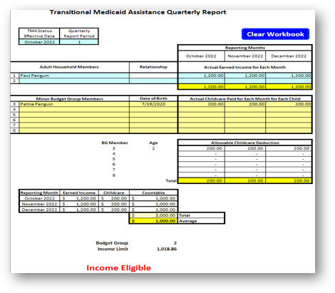
After the beneficiaries enter their TMA2 period the system will generate and send out required Quarterly Reports. The eligibility specialist must re-determine continued eligibility based on the information provided on the quarterly report and any verification provided. The eligibility specialist will enter the household information into the TMA QR tab of the MAGI workbook.

Enter the actual earned income that was verified for the quarter that was reported by the beneficiary.

Enter any childcare paid during that quarter. A max of $200 is allowed in deductible childcare expense. The attestation of childcare is acceptable.

Based on the income entered the workbook tab will show if the household is Income Eligible.

